Installing DESpy using Spyder

This assumes that Anaconda Spyder has already been installed. If not, then download and install from <https://www.anaconda.com/download>. The version as of this writing is Anaconda3.

# Installing on Windows

The default Anaconda3 install location is C:\ProgramData\Anaconda3.

Open up a command prompt (type “cmd” in the run area) and enter:

C:\ProgramData\Anaconda3\python.exe -m pip install --upgrade DESpy

You should see something similar to:

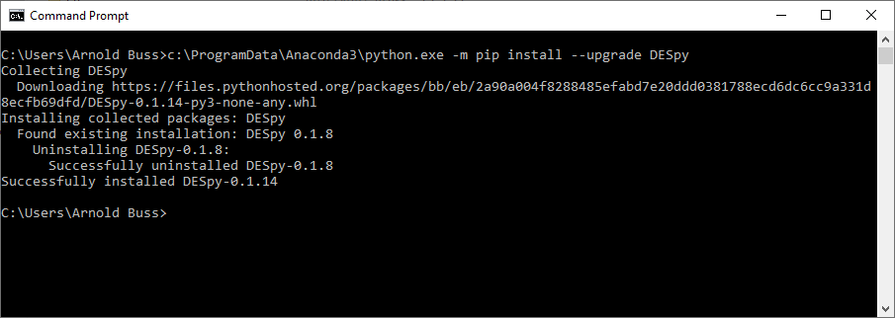

If your Anaconda is installed in a different location, use that.

# Installing on Mac OS

The location is slightly different on Mac. Open a Terminal and enter:

/anaconda3/bin/python -m pip install DESpy

You should see something similar to:



If you have chosen “just me” when installing Annaconda, use:

~/anaconda3/bin/pip install –upgrade DESpy